Atmanand Saraswati Science College

**Bachelor of Computer Application Programme**

**(T.Y.B.C.A. SEMESTER - V)**

# Project Report On

# BookMyTable Website

**Submitted By: Name:** **MORADIYA NENSI J.**

**Exam No.: 6723 Roll No.: BCA21142**

**Guided By: Dr. Jasmin Bhootwala**

Atmanand Saraswati Science College

**C E R T I F I C A T E**

This is to certify that Mr./Ms. **_MORADIYA NENSI JAYSUKHBHAI** examination number **6723** has satisfactorily completed his / her minor project work entitled **_BookMyTable Website** as partial fulfillment of requirements for T.Y.B.C.A. Semester – V, during the academic year 2023-24.

Date: 17/06/2021

Place: Surat (Dr. Shailesh C. Padsala)

I/C Principal

Atmanand Saraswati Science College,

Surat

**ACKNOWLEDGEMENT**

I would like to express my gratitude and appreciation to all those who gave me the possibility to complete this project. Special thanks are to my mentor Jasmin Bhootwala whose help, stimulating suggestions and encouragement helped me in all time of fabrication process and in writing this report. I also sincerely thanks for the time spent proofreading and correcting my many mistakes.

I would also like to acknowledge with much appreciation the crucial role of the staff in B.C.A. Laboratory, who gave me a permission to use the lab equipment and also the machine and to design the drawing and giving a permission to use all the necessary tools in the laboratory.

Many thanks go to the all lecturers who have given their full effort in guiding me in achieving the goal as well as their encouragement to maintain our progress in track. My profound thanks go to all classmates, especially to my friends for spending their time in helping and giving support whenever I need it in fabricating my project.

**ABSTRACT**

Title: BookMyTable website

In a world marked by busy schedules and a growing culinary culture, the "BookMyTable" website emerges as a dynamic and user-centric solution, transforming the way diners reserve tables at their favorite restaurants. Built using PHP and MySQL, this online platform serves as a bridge between discerning diners and restaurants eager to enhance their customer experience.

BookMyTable offers a user-friendly interface, enabling diners to effortlessly search, browse, and reserve tables, eliminating the hassle of traditional booking methods. The platform boasts an extensive database of restaurants, each detailed with comprehensive information, including cuisine types, locations, menus, and user- generated reviews, empowering users to make informed dining choices.

One of the website's standout features is its real-time table availability checker, ensuring users secure reservations that align perfectly with their schedules. For restaurant operators, the website offers a robust reservation management system, simplifying the process of handling bookings and optimizing seating arrangements.

Personalization is at the heart of BookMyTable, with user profiles enabling individuals to save preferences, review reservation history, and receive tailored recommendations. Automated notifications via email or SMS confirm reservations and provide timely reminders, enhancing the overall user experience.

The platform encourages user engagement through ratings and reviews, facilitating informed dining decisions. With secure payment integration, users can pre-pay for reservations, streamlining the booking process. The responsive design ensures accessibility across devices, from smartphones to desktops.

Advanced search and filter options allow users to pinpoint restaurants based on specific criteria like cuisine, location, and price range. Meanwhile, restaurant owners gain access to performance analytics and reports, enabling data-driven decision-making and customer satisfaction optimization.

BookMyTable represents a significant step forward in the dining industry, where convenience meets culinary delight. Its robust PHP and MySQL foundation ensures reliability and scalability, making it a must-have tool for both diners seeking memorable dining experiences and restaurants eager to excel in a competitive landscape.

In a world where dining out is more than just sustenance, BookMyTable brings innovation to the table, offering an unparalleled dining reservation experience.

**Table of Content**

|  |  |  |
| --- | --- | --- |
| **Sr. No.** | **Description** | **Page No.** |
| **1** | **Introduction** | **1** |
| **2** | **Environment Description** | **2** |
|  | 2.1 Hardware Requirements | **2** |
|  | 2.2 Software Requirements | **2** |
| **3** | **System Analysis and Planning** | **3** |
|  | 3.1 Existing System and its drawbacks | **3** |
|  | 3.2 Feasibility study | **5** |
| **4** | **Proposed System** | **7** |
|  | 4.1 Scope | **7** |
|  | 4.2 Project modules | **7** |
|  | 4.3 Module wise objectives and functionalities | **7** |
| **5** | **Detail Planning** | **9** |
|  | 5.1 Data flow diagram | **9** |
|  | 5.2 Data dictionary | **10** |
|  | 5.3 Entity – Relationship Diagram | **10** |
| **6** | **System Design** | **11** |
|  | 6.1 Input design | **11** |
|  | 6.2 Output design | **11** |
|  | 6.3 Screenshots of the system | **11** |
| **7** | **Software Testing** | **16** |
| **8** | **Limitations and Scope of Enhancement** | **17** |
| **9** | **References** | **18** |

# Introduction

BookMyTable is a user-friendly online platform that revolutionizes dining reservations. With an extensive network of restaurants, it offers customers a hassle-free way to discover, browse, and book tables at their favorite eateries. The website provides detailed information about each restaurant, including menus, reviews, and ratings, allowing users to make informed choices. BookMyTable also offers exclusive deals and discounts, making dining out more affordable. Whether it's a romantic dinner, a family celebration, or a business meeting, BookMyTable simplifies the reservation process, ensuring a delightful dining experience. Say goodbye to waiting in long queues or making endless phone calls – BookMyTable is your go-to destination for seamless restaurant bookings.

# Environment Description

* 1. **Hardware Requirements**

The BookMyTable website requires following technical specifications to run properly and efficiently.

* + - **Hardware**
      * Intel(R) Core (TM) i3-4005U CPU @ 1.70GHz 1.70GHz
      * 2.00GB RAM
  1. **Software Requirements**
     + **Software**
* Visual Studio Code
* MYSQL
* XAMMP

# System Analysis and Planning

* 1. **Existing System and its drawbacks**
     + **front end**

PHP (or PHP Hypertext Preprocessor) is a server-side scripting language that is used to create dynamic web pages that can interact with databases. It is a widely-used open source language that is specifically used for web application development and can be embedded within HTML.

The distinguishing feature of PHP is that the scripting code is executed on the server, which generates HTML that is sent back to the client. The client receives the result of executing the script without knowing the underlying code. Developers can configure the web server to process all the HTML files (containing the PHP script).

PHP, as a scripting language, is popular among web developers because of its ability to interact with database systems including Oracle and MySQL.

This article discusses the use of PHP scripting language with the MySQL database. Any website can require a variety of data or information to display and to retrieve them from the database. This can include display of a simple list to the running of the website based on data stored in the database.

[Like](https://www.knowledgehut.com/web-development/fullstack-development-bootcamp-training) any other scripting language, PHP is fundamentally the tool you use to connect to your database to get information and hand that information over to your web server to be displayed [in HTML.](https://www.knowledgehut.com/blog/web-development/install-angular-cli) But many aspects of PHP set it apart from other languages. PHP is

* **A Scripting Language**: Scripting languages are interpreted by another program at runtime (no need for compilation). Scripting languages can be interpreted server-side or client-side (in the browser).
* **Server-Side**: PHP is a server-side scripting language processed by a PHP

interpreter on a web server; the result (the output) is sent to the web browser as plain HTML.

* **Open-Source**: PHP is freely available to download and use.
* **Object-Oriented**: Object-Oriented Programming (OOP) leverages the concept of “objects” to contain data and functions to help build more complex, reusable web applications. OOP was added to PHP5.
  + **Fast**: PHP uses its memory, minimizing server workload and increasing performance. PHP can be up to 382% faster than Python and 195% faster than Ruby.
  + **Simple**: The PHP syntax is easily understood and learned, whether you’re building from scratch or leveraging existing frameworks or add-ons.
  + **Well Supported**: PHP supports all leading databases (MySQL, SQLite, ODBC) and is compatible with most servers (Apache, IIS, etc.). It is portable across all platforms (Windows, Mac OS, Linux, etc., and can be further supported by PHP frameworks (Laravel, CodeIgniter, Symfony) and many well-stocked and vetted libraries.

## Back end

MySQL is a relational database management system (RDBMS) developed by Oracle that is based on structured query language (SQL).

[MySQL is one of the](https://www.digitalocean.com/community/tutorials/json-server" \l "installing-json-server) [most](https://www.digitalocean.com/community/tutorials/json-server#installing-json-server) recognizable technologies in the modern big data ecosystem. Often called the most popular database and currently enjoying widespread, effective use regardless of industry, it’s clear that anyone involved with enterprise data or general IT should at least aim for a basic familiarity of MySQL.

With MySQL, even those new to relational systems can immediately build fast, powerful, and secure data storage systems. MySQL’s programmatic syntax and [interfaces are also](https://www.digitalocean.com/community/tutorials/json-server" \l "run-json-server) perfect gateways into the wide world of other popular query [languages and](https://www.digitalocean.com/community/tutorials/json-server#run-json-server) [structured](https://www.digitalocean.com/community/tutorials/json-server#run-json-server) data stores.

## [The MySQL CREATE](https://www.digitalocean.com/community/tutorials/json-server" \l "json-server-custom-routes) [DATABASE](https://www.digitalocean.com/community/tutorials/json-server#json-server-custom-routes) Statement

CREATE DATABASE databasename;

## The MySQL CREATE TABLE Statement

CREATE TABLE table_name ( column1 datatype, column2 datatype, column3 datatype,

....

);

Open source means it’s possible for anyone to use and modify the software. Anybody can download MySQL software from the internet and use it without paying for it. You can also change its source code to suit your needs. MySQL software uses the GNU General Public License (GPL) to define what you may and may not do with the software in different situations.

If you feel uncomfortable with the GNU GPL or need to embed MySQL code into a commercial application, you can buy a commercially licensed version from Oracle. See the MySQL Licensing Information section for more information.

* 1. **Feasibility study**

Not everything imaginable is feasible, not even in software, evanescent at it appears to outsiders. The feasibility study is done to decide whether we should undergo in taking project or not. And select the project only if it is feasible in terms of cost, time, technology and

resources and also Operational feasibility is involved in considering a project.

On the contrary, software feasibility has four solid dimensions.

## Technological feasibility:

Technological feasibility includes various aspects such as:

* Whether the project is technically feasible?

Our project is technically feasible. The technology we are using or implementing in our software is easily available and is user friendly.It is also compatible with the current computer system used nowadays.

* Can it be reduced to a level matching the applications need?

Yes, the software can be reduced to the level matching application needs. The computer language we are using is complete advanced one though; it has facility of reducing to the level of our application.

## [Financial Feasibility:](https://colorwhistle.com/core-web-vitals-guide/)

It includes basic two aspects:

* Is it financially feasible?

The software which we are developing is financially feasible,as it requires a minimum of desktop computer with basic peripherals and two easily available software.

* Can development be completed at a cost of the software organization, it's client, or the market can afford?

Yes,the software we are developing can be completed at the cost of organization's clients. Market can easily afford the software as its costing is not going to be unfeasible.

## Time Feasibility:

It includes the main aspect of being the markets competition within the time.

The software is fully compatible with the soft-wares present in market related to club management system. There are many other extra feature which beat the market that to within the given time limit.

## Resources Feasibility:

1. The resources available in company are sufficient to develop

the software. They are fully updated and are ready to use. Thus, the software is feasible from resources point of view.

* 1. **Scope**

# Proposed System

The scope of a "BookMyTable" website can encompass various aspects and functionalities to create a comprehensive and user-friendly platform for both diners and restaurants

* Here's an overview of the potential scope for such a website:
  + User Registration and Profiles:
  + Real-Time Reservation System:
  + Responsive Design
  + Admin Dashboard

◻User-Friendly Search and Filters

* 1. **Project Modules**

1. User Management Module
2. Reservation Module
3. User Interaction Module
4. Responsive Design Module
5. Admin Module
6. Security Module
7. Marketing and Promotions Module
   1. **Module wise objectives and functionalities**

There are a number of factors in the client’s environment that may restrict the choices of a designer. Such factors include standards that must be followed, resource limits,

operating environment, reliability and security requirements and policies that may have an impact on the design of the system.

## Standard Compliances:

This specifies the requirement for standards the system must follow. The standards may include the report format and accounting properties

## Hardware Limitations:

Hardware limitations can include the types of machine to be used, operating system available on the system, languages support and limits on primary and secondary storage.

## Reliability and Fault Tolerance:

Fault tolerance requirement can be place a constraint on how the system is to be

designed. Recovery requirements are often on integral part here, detailing what the system should do if some failure occurs to ensure certain properties. Reliability requirements are very important for critical application.

## Security:

Security requirements are particularly significant in defense system and database system. They place restrictions on the use of certain commands, control access to

data, provide different kinds of access requirements for different people, require the use of passwords and cryptography techniques and maintain a log of activities in the

system.

# Detail Planning

* 1. **Data flow diagram**
     + **Admin**

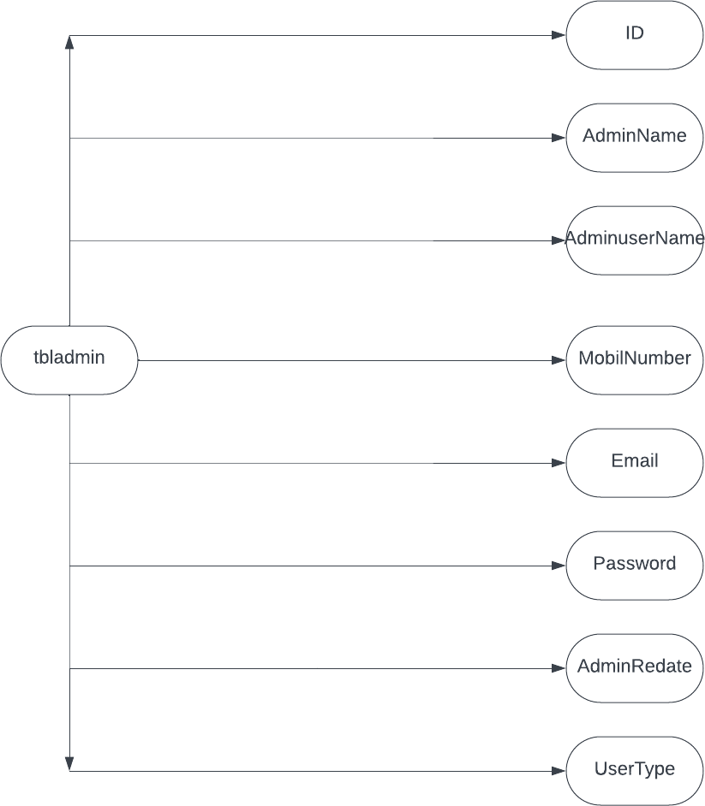

* + - **Bookings**

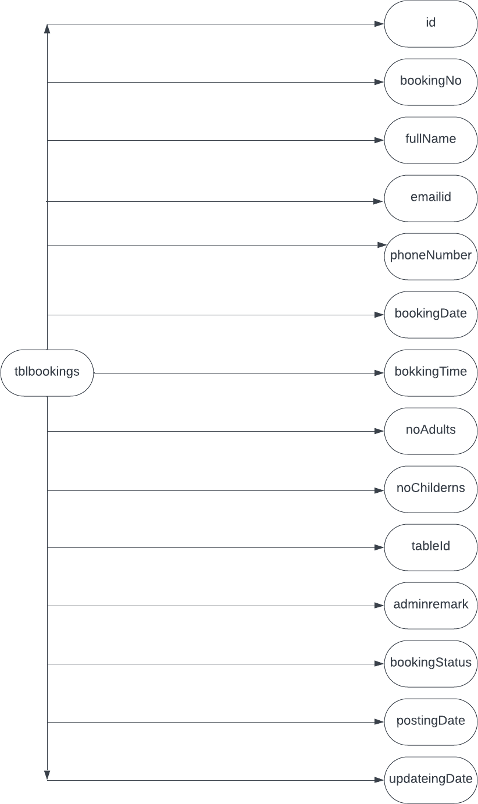

* + - **table Reservation**

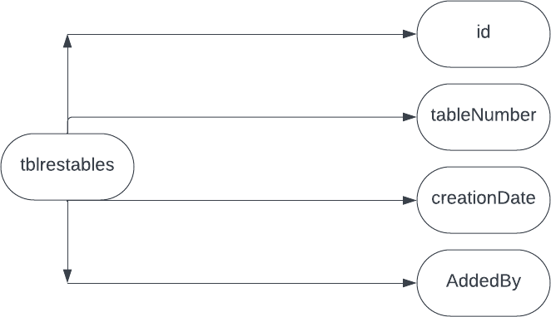

* 1. **Data Dictionary**
  2. **Entity – Relationship diagram**

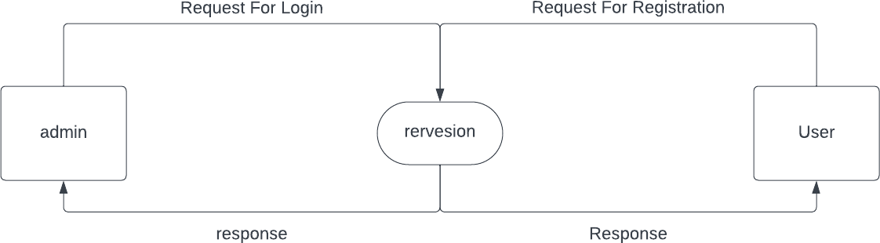

# System Design

* 1. **Input Design**
  2. **Output Design**
  3. **Screenshots Of the system**
     + **Admin Login**

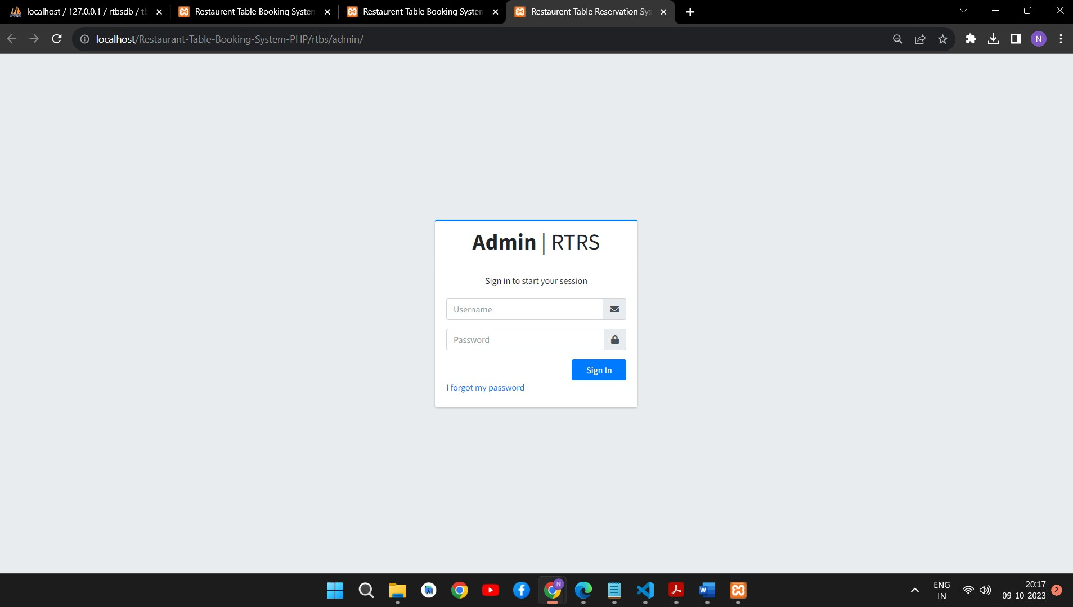

* + - **Book table**

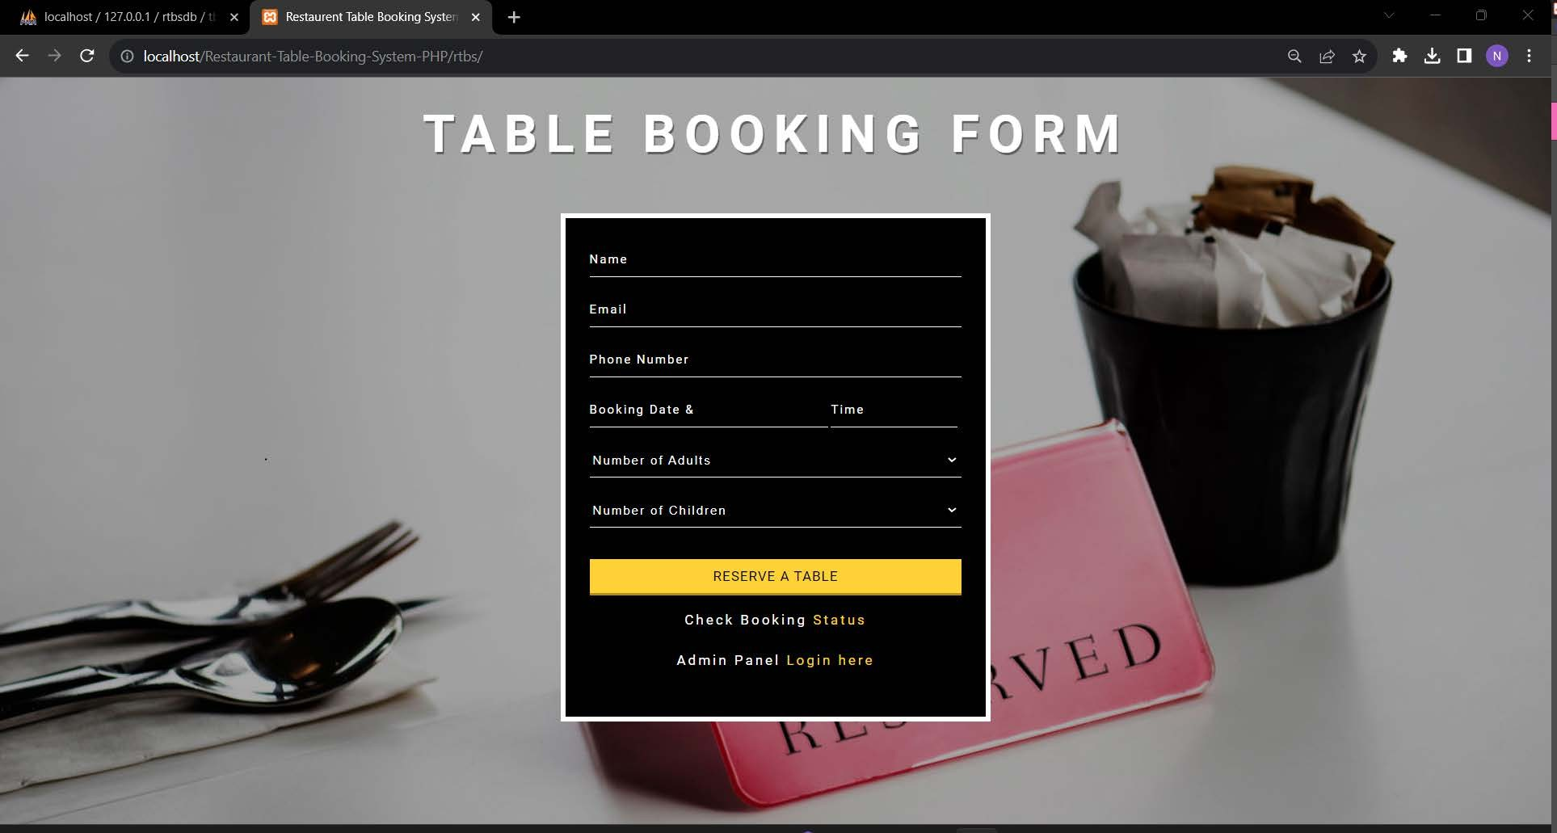

* **Admin dashboard**

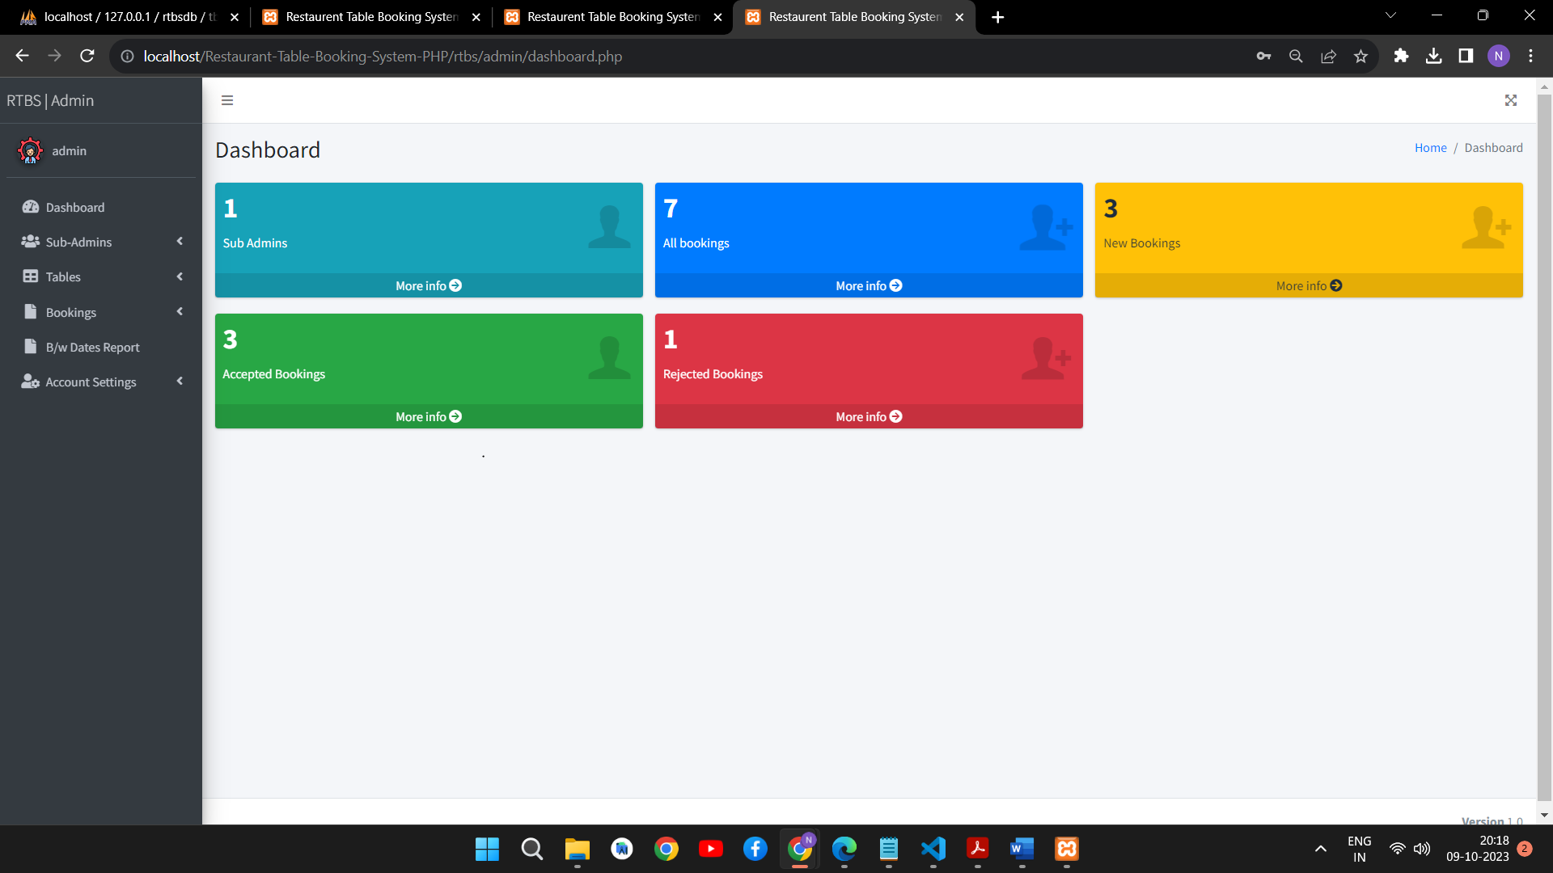

* + **Search**

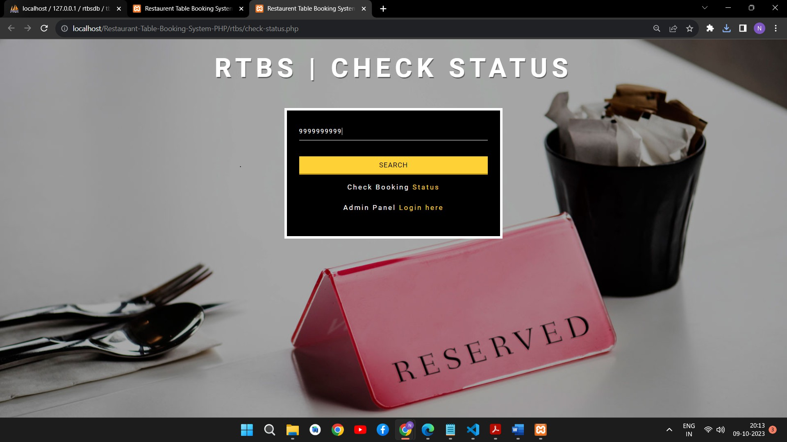

* + - **Rejected booking details**

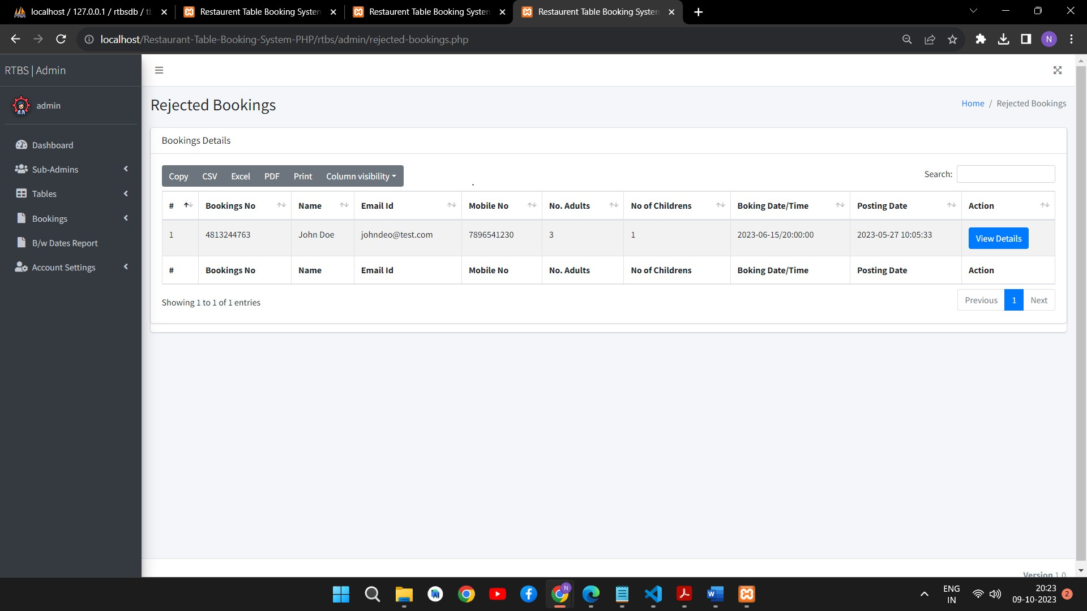

* **Confirm booking**

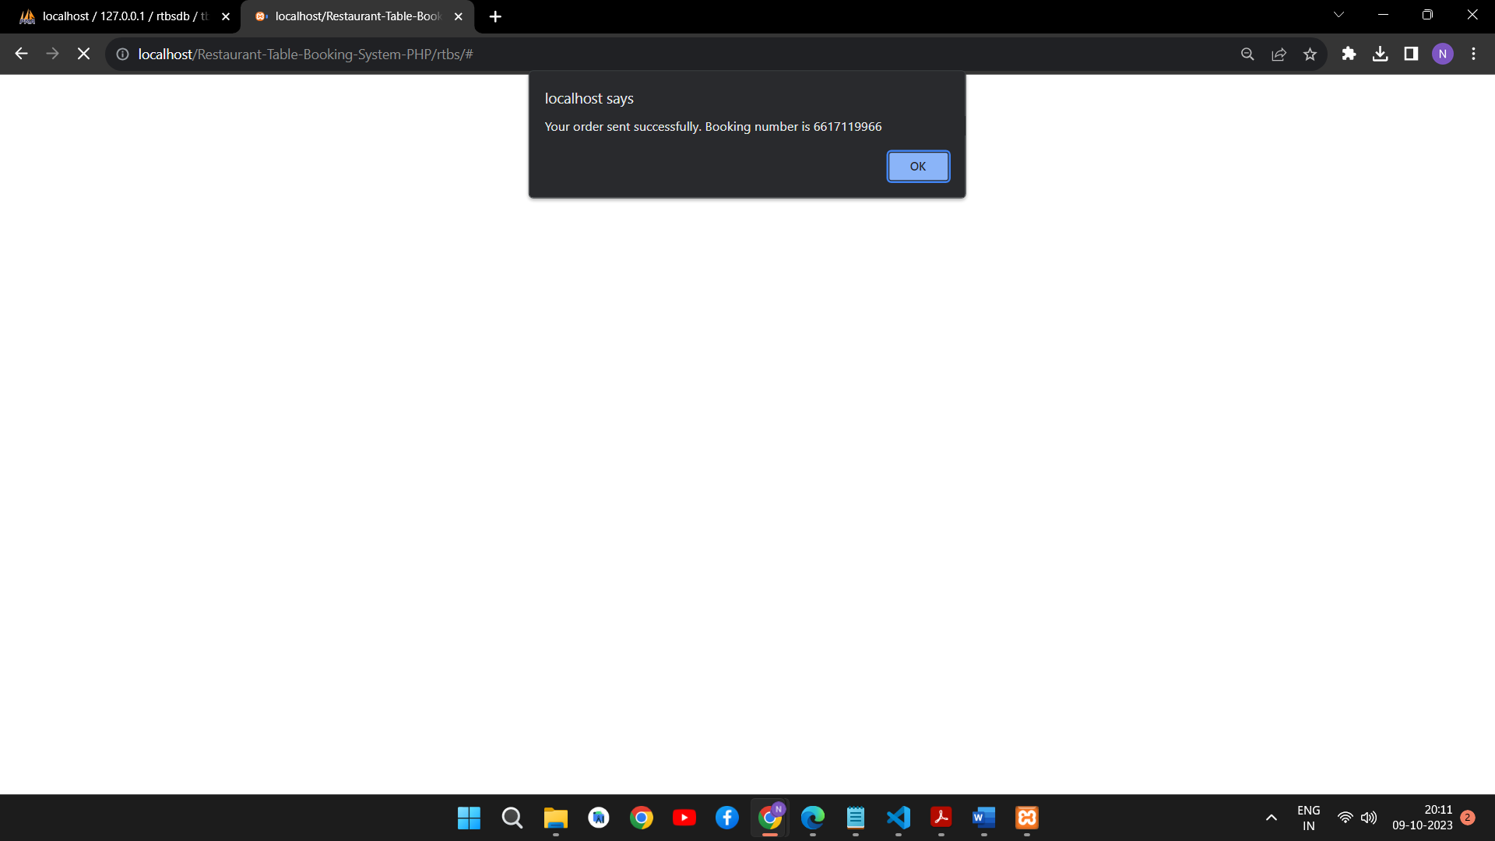

* + **New booking Details**

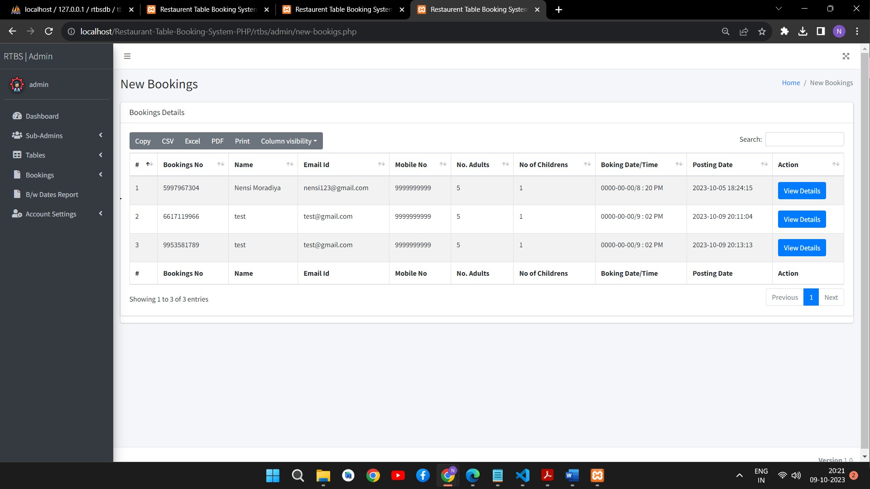

* + **All Booking Details**

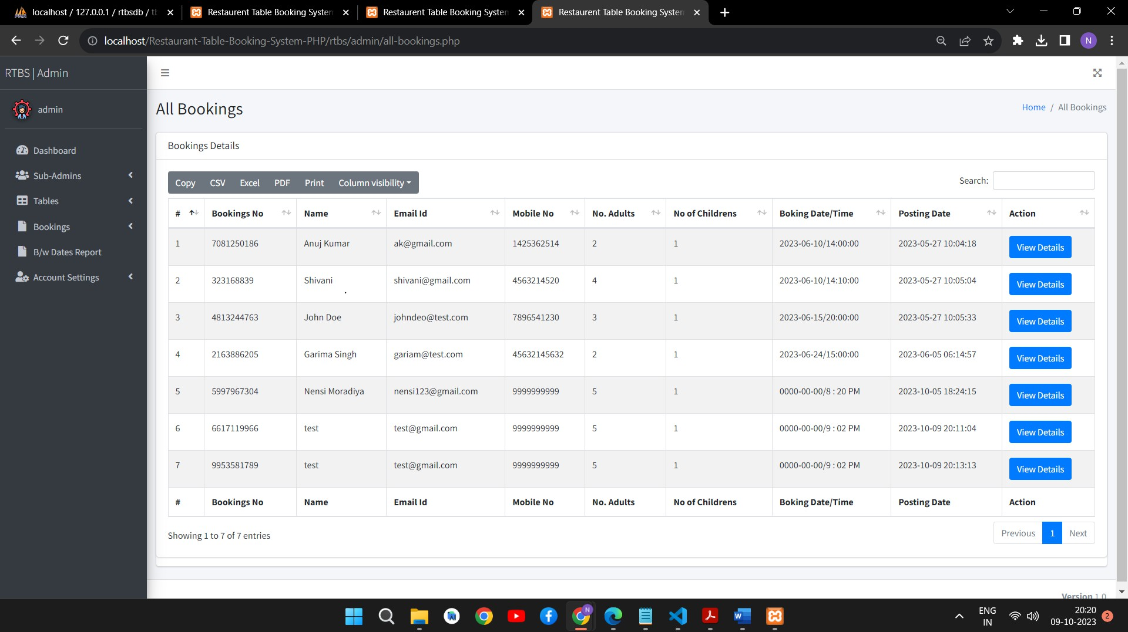

# Software Testing

The testing process focuses on the logical intervals of the software ensuring that all statements have been tested and on functional interval is conducting tests to uncover errors and ensure that defined input will produce actual results that agree with the required results. Program level testing, modules level testing integrated and carried out.

## Functional Testing:

All web page is working properly. All navigation work properly.

MySQL database work Proper. All Pages Design is perfect

## Environment Testing :

Internet explorer and chrome consider testing for environment operability of software.

Web server - Apache/MySQL

Database – MySQL

OS – Windows 11

Browser – Internet Explorer/Chrome

# Limitations and Future Scope of Enhancement

## Limitations

lthough I have put my best efforts to make the software flexible, easy to operate but limitations cannot be ruled out even by me. Though the software presents a broad range of options to its users some intricate options could not be covered into it; partly because of logistic and

partly due to lack of sophistication. Paucity of time was also major constraint, thus it was not possible to make the software foolproof and dynamic.

Lack of time also compelled me to ignore some part such as storing old result of the candidate etc.

## Scope:

The future scope includes expand the technologies like HTML and Angular we can also add new technologies like Laravel, reactjs many more for improving the

efficiency of the software.

The Online Flight Booking system is the next generation address book which will provide these two basic services like portability, security.

The project will be useful for any schools and colleges with slightly modification. Project is flexible ie. any change /modification in database may be performing easily.

* This project can be upgraded by adding more options such as Ticket editing and more admin operations.
* Payment options and document checking such as ID proofs can be added.

Applications can be upgraded by improving performance as per user feedback.

# References

* https://[www.codewithharry.com/](http://www.codewithharry.com/)
* https://getbootstrap.com/
* https://[www.w3schools.com/](http://www.w3schools.com/)
* https://developer.mozilla.org/en-US/docs/Web

